



Excel and Copilot for Data Productivity
LAB MANUAL

Disclaimer: The content is curated from online/offline resources and used for educational purpose only
Lab 1.2 - Creating Pivot Tables & Charts
Task:
To create Pivot Tables and Charts
Objective
To enable learners to summarize and visualize large datasets dynamically using Pivot Tables for aggregation and Pivot Charts for graphical representation.
Equipment Required
- A computer with Microsoft Excel installed.
- Use the dataset – Lab 1.2 - Dataset.xlsx
Prerequisites
- Familiarity with basic Excel navigation, data entry, and simple formulas.
- Completion of prior tasks including data cleaning and summarization techniques.
Problem Statement
Given a cleaned dataset of student records (including fields such as Subject, Marks, and Attendance), create Pivot Tables to calculate key metrics (e.g., average marks by Subject, count of attendance codes) and generate Pivot Charts to visualize these summaries.

Procedure
Step 1: Select the Dataset Range - Click anywhere within the table of data or manually select the full range (including headers).
Step 2: Insert a PivotTable - Navigate to the Insert tab and click PivotTable. In the dialog, confirm the selected range and choose whether to place the Pivot Table in a new worksheet or an existing one. Click OK.
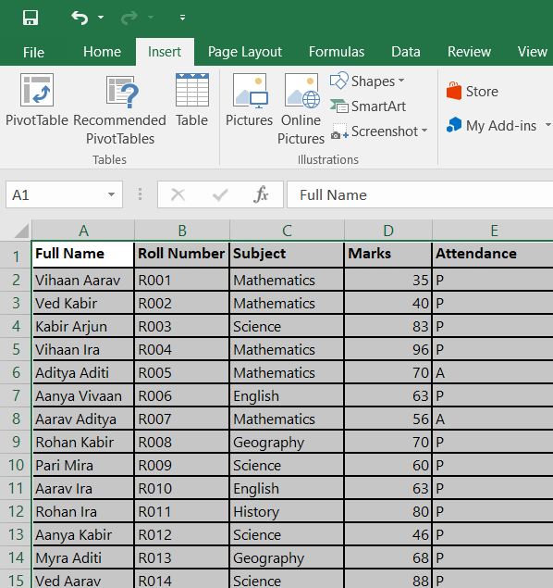
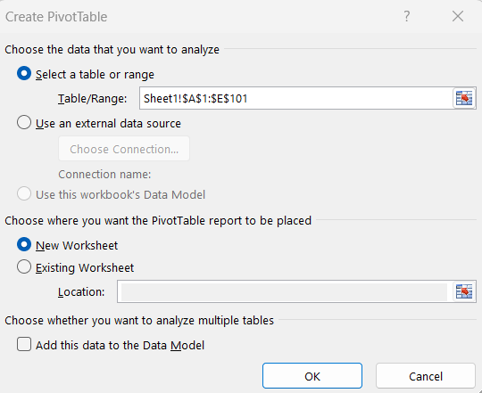

Step 3: Configure Row and Column Fields - In the Pivot Table Fields pane, drag a categorical field (e.g., Subject) to the Rows area. For a secondary breakdown (e.g., Attendance), drag Attendance to Columns.
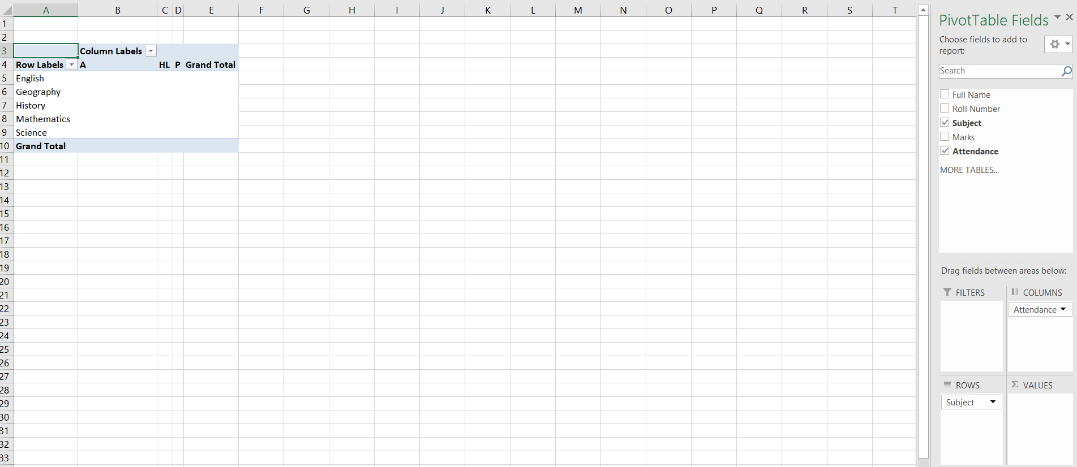
Step 4: Add Values for Aggregation - Drag a numerical field (e.g., Marks) to the Values area. By default, Excel will apply the Sum function.
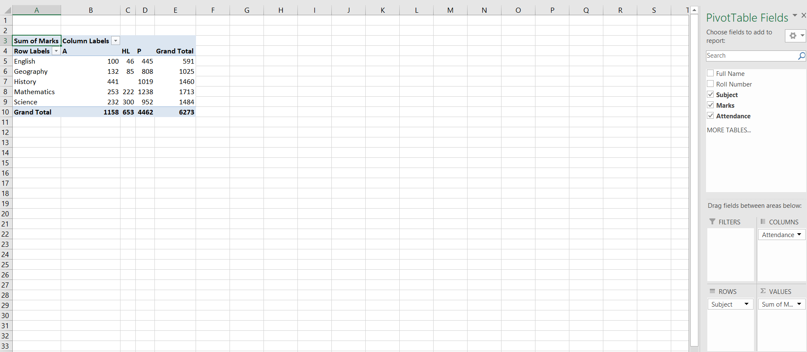

Step 5: Change Value Field Settings - Click the dropdown arrow next to the field in the Values area and choose Value Field Settings. Change the function to Average or Count as needed, then click OK.
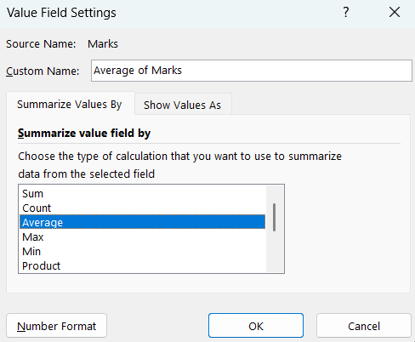
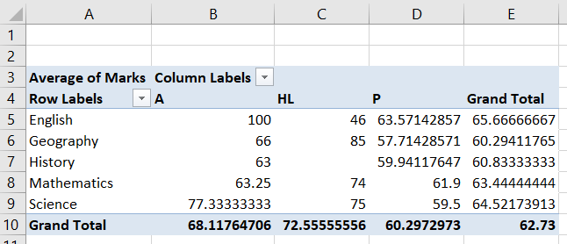

Step 6: Insert a PivotChart - With any cell in the PivotTable selected, go to the PivotTable Analyze (or Analyze) tab, click PivotChart, and choose a chart type (e.g., Column, Bar, Pie). Click OK.
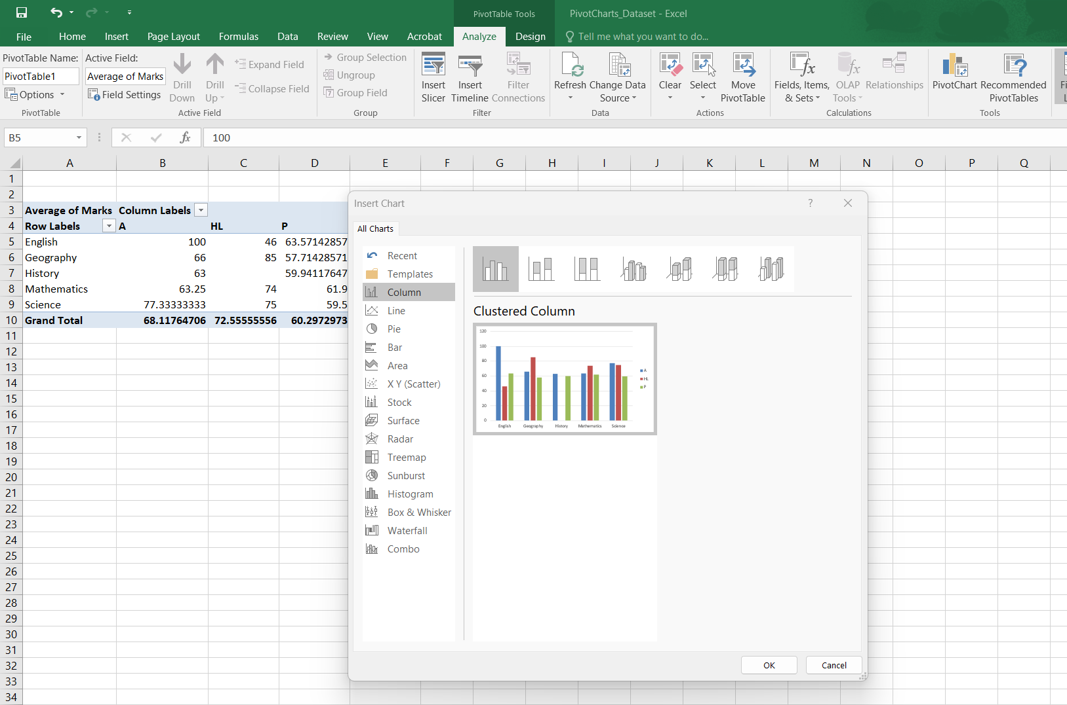

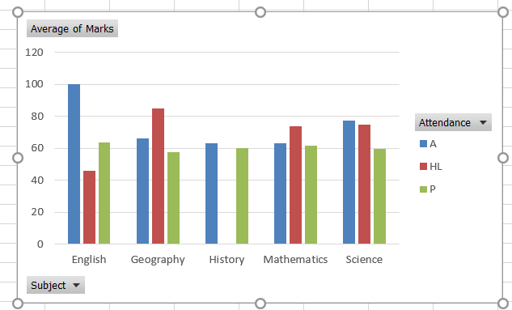
Step 7: Filter and Slicer Configuration - To enable interactive filtering, drag a field (e.g., Attendance) to the Filters area or insert a Slicer via PivotTable Analyze → Insert Slicer, select the field, and click OK.
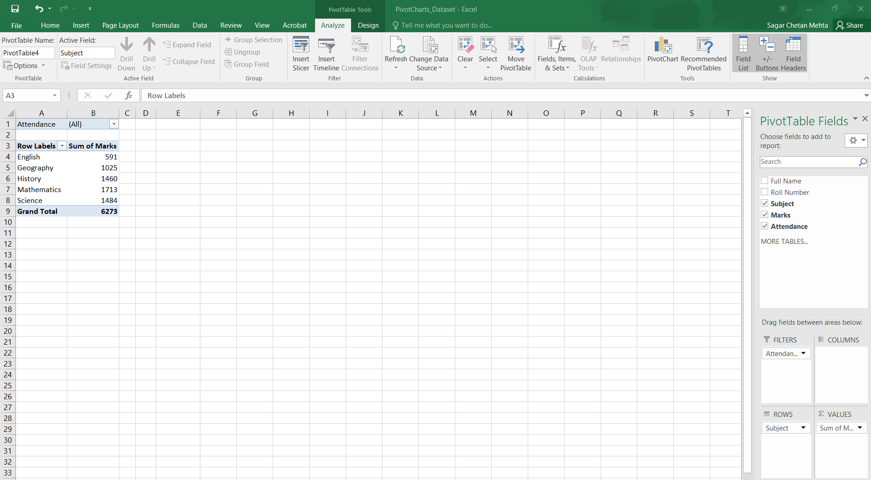
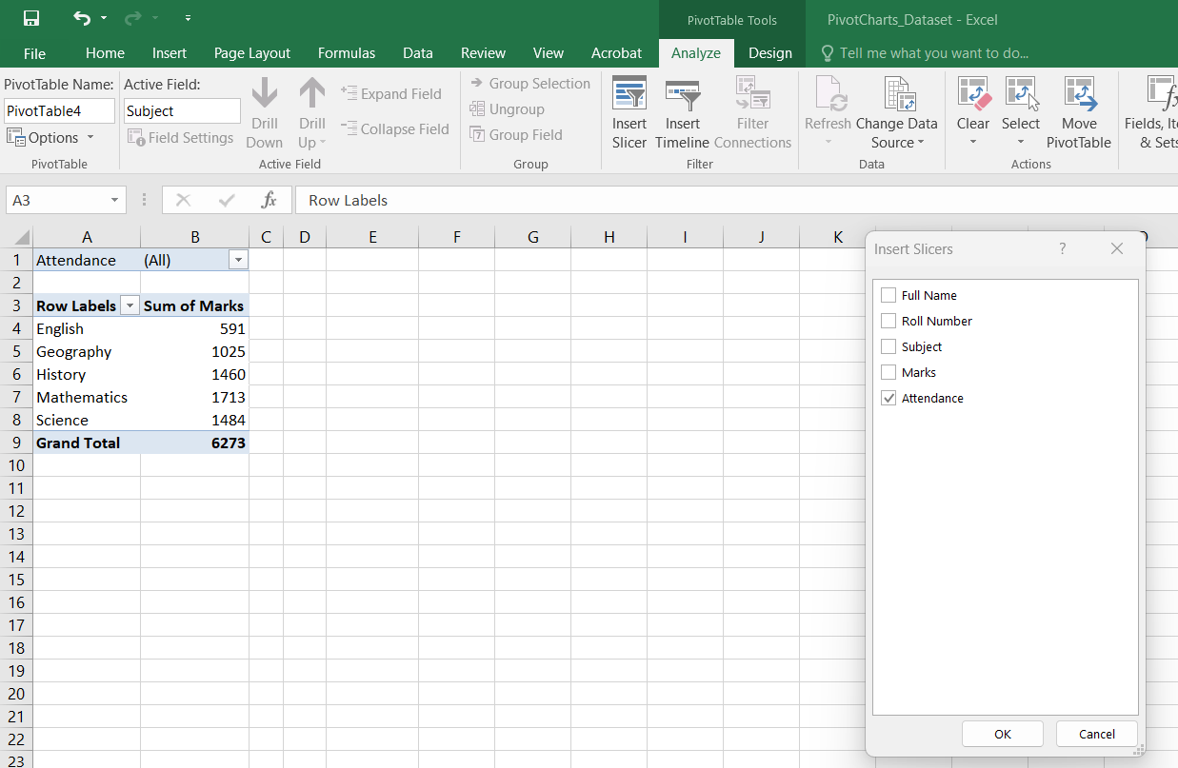

Output 1
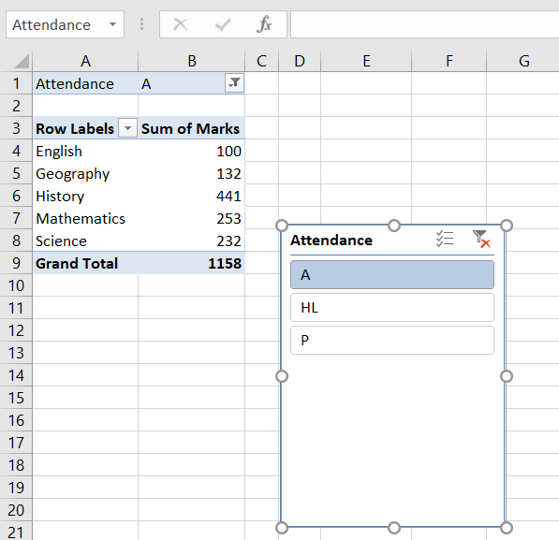
Output 2
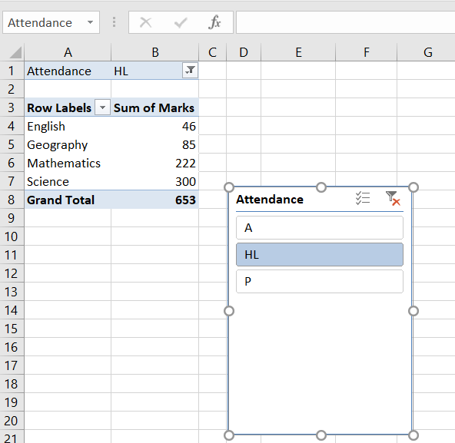
Step 8: Save the Workbook - Save your applied formatting by clicking File > Save or using the keyboard shortcut:
- Windows/Linux: Ctrl + S
- macOS: Command + S

